**Mode Card Software Architecture Design**

Compliance with ASPICE, ISO 26262, ISO/SAE 21434 Standards

☑ ASPICE-1/2/3/4/5 □ ASIL-A/B/C/D □ CAL-1/2/3/4

Issued by Ford ECDX

|  |  |  |  |
| --- | --- | --- | --- |
| Prepared by | Jiawei Li | Audited by |  |
| Reviewed by |  | Approved by |  |
| Issue By | Jiawei Li | Receiver |  |
| Deposit address |  | | |
| Upstream doc. |  | | |
| Downstream doc. |  | | |
| Secret Request | N/A | Text Format | N/A |
| Expire Years | 2037 | Current State | Draft×baseline×publish√ |

**Change History**

| Version | | Date | Author | Approve | Changes |
| --- | --- | --- | --- | --- | --- |
| Current | New |
| --- | 0.1 | 2022.12.21 | Li Jiawei |  | Initial Version |
| 0.1 | 0.2 | 2023.01.03 | Li Jiawei |  | 1. add key component description of static architecture  2. add key sequence diagram |
| 0.2 | 0.3 | 2023.01.09 | Li Jiawei |  | 1. update static architecture diagram  2. add “startup mode card process” sequence diagram  3. add “view recommend card list” sequence diagram  4. add “view custom card list” sequence diagram  5. add “run camp mode” sequence diagram  6. update “create a custom card mode” sequence diagram |
|  |  |  |  |  |  |
|  |  |  |  |  |  |
|  |  |  |  |  |  |
|  |  |  |  |  |  |
|  |  |  |  |  |  |
|  |  |  |  |  |  |
|  |  |  |  |  |  |

List of content

1. Outline 5

1.1 Objectives 5

1.2 Reference documents 5

1.3 The definition of terms, abbreviations, and etc 5

2. Constraint Conditions 6

2.1 The Constraints of Hardware 6

2.2 The Constraints of Software 6

2.3 The Constraints of Manufacturing Process 6

2.4 The Constraints of Service and Maintenance After Shipment 6

3. Software Design 7

3.1 Software Static Architecture 7

3.1.1 External module dependencies diagram 7

3.1.2 Software Architecture Diagram 8

3.1.3 COMP_01: Custom Mode 9

3.1.4 COMP_02: Trigger Manager(To be Update) 9

3.1.5 COMP_03: Executor Manager(To be Update) 10

3.1.6 COMP_04: Terminator Manager(To be Update) 11

3.1.7 COMP_05: Card Manager(To be Update) 12

3.2 Software Dynamic Architecture 13

3.2.1 Function 13

3.2.1.1 Startup Mode Card Process 13

3.2.1.2 View Recommend Card List 14

3.2.1.3 View Custom Card List 15

3.2.1.4 Create a custom Card Mode 16

3.2.1.5 Run a Card Mode（To be update） 17

3.2.1.6 Terminate a Card Mode（To be update） 18

3.2.1.7 Run Camp Mode 19

3.2.2 Safety Mechanism_ASIL 20

4. Detailed Interface 21

4.1 Component Interface 21

4.2 Hardware – Software Interface 21

5. Software control Strategy 22

5.1 Time Constrains Design and Estimation 22

5.2 Task Management 22

5.3 Interrupt Service Routines 22

5.4 Initialization Processing 22

5.5 Watch Dog 22

5.6 Shared Resources 22

6. Resource Estimation 22

6.1 Memory Size Estimation 22

6.2 CPU Load Estimation CPU 22

# 

# Outline

## Objectives

This is Mode Card SW design to guide developer to implement features, forwarding is forbidden without concurred by author

## Reference documents

| No. | Reference Document. | Version | Issuer | Reason. |
| --- | --- | --- | --- | --- |
| 1 | Mode Card 1.0 PRD 场景卡片_V1.0_20221210 | V1.0 | Geng Dekang |  |
| 2 | Camp Mode_PRD_V1.0_20221125 | V1.0 | Ni Anthony |  |
| 3 | Pet Mode 0.3 PRD_ 20221216 | V0.3 | Hu Lina |  |
| 4 | Battery Save Mode 0.1 PRD_ 20221214 | V0.1 | Hu Lina |  |

## The definition of terms, abbreviations, and etc

| No. | Terms and Abbreviations. | Meanings, Definitions and Official Name. |
| --- | --- | --- |
| 1 | Co., Ltd. | Company Limited |
| 2 | CPU | Central Processing Unit |
| 3 | e.g. | exempli gratia |
| 4 | I/O | Input/Output |
| 5 | ISR | Interrupt Service Routine |
| 6 | OS | Operating Software |
| 7 | RAM | Random Access Memory |
| 8 | ROM | Read Only Memory |
| 9 | RTOS | RealTime Operating Software |
|  |  |  |
|  |  |  |

# Constraint Conditions



## The Constraints of Hardware

* CX727 ICA Bench，including Silver Box, Display Screen, DSP & Cables
* CX821 Bench，including Silver Box, Controller Screen , Pano Screen, DSP & Cables

## The Constraints of Software

## The Constraints of Manufacturing Process

* N/A

## The Constraints of Service and Maintenance After Shipment

* N/A

# Software Design



## Software Static Architecture



### External module dependencies diagram

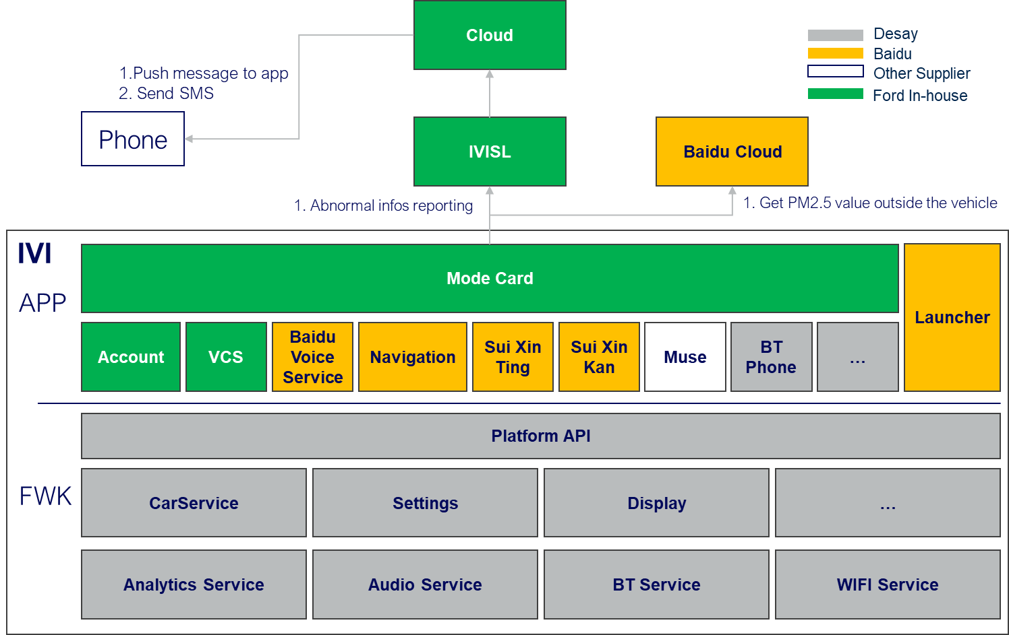

**CX727 ICA**

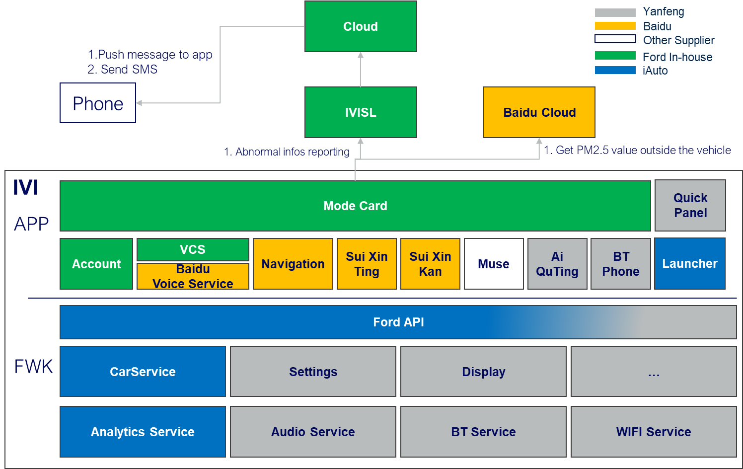

**CX821**

### Software Architecture Diagram

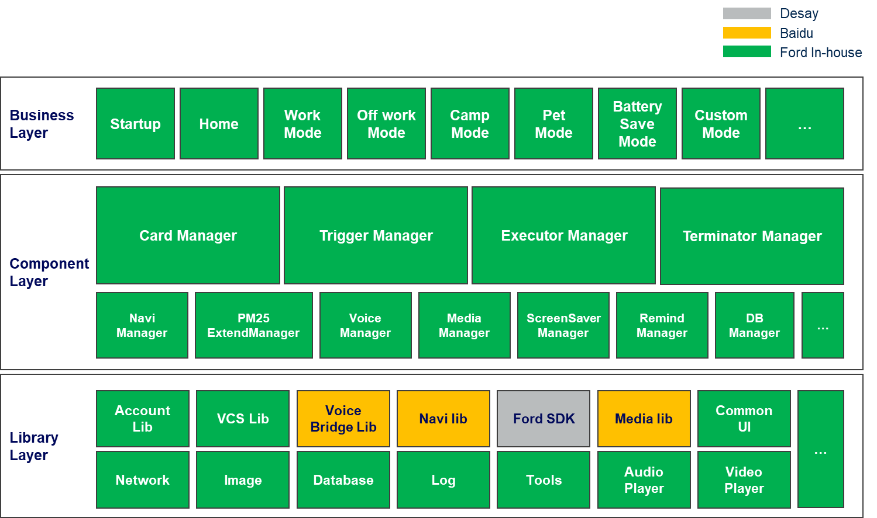

**CX727 ICA**

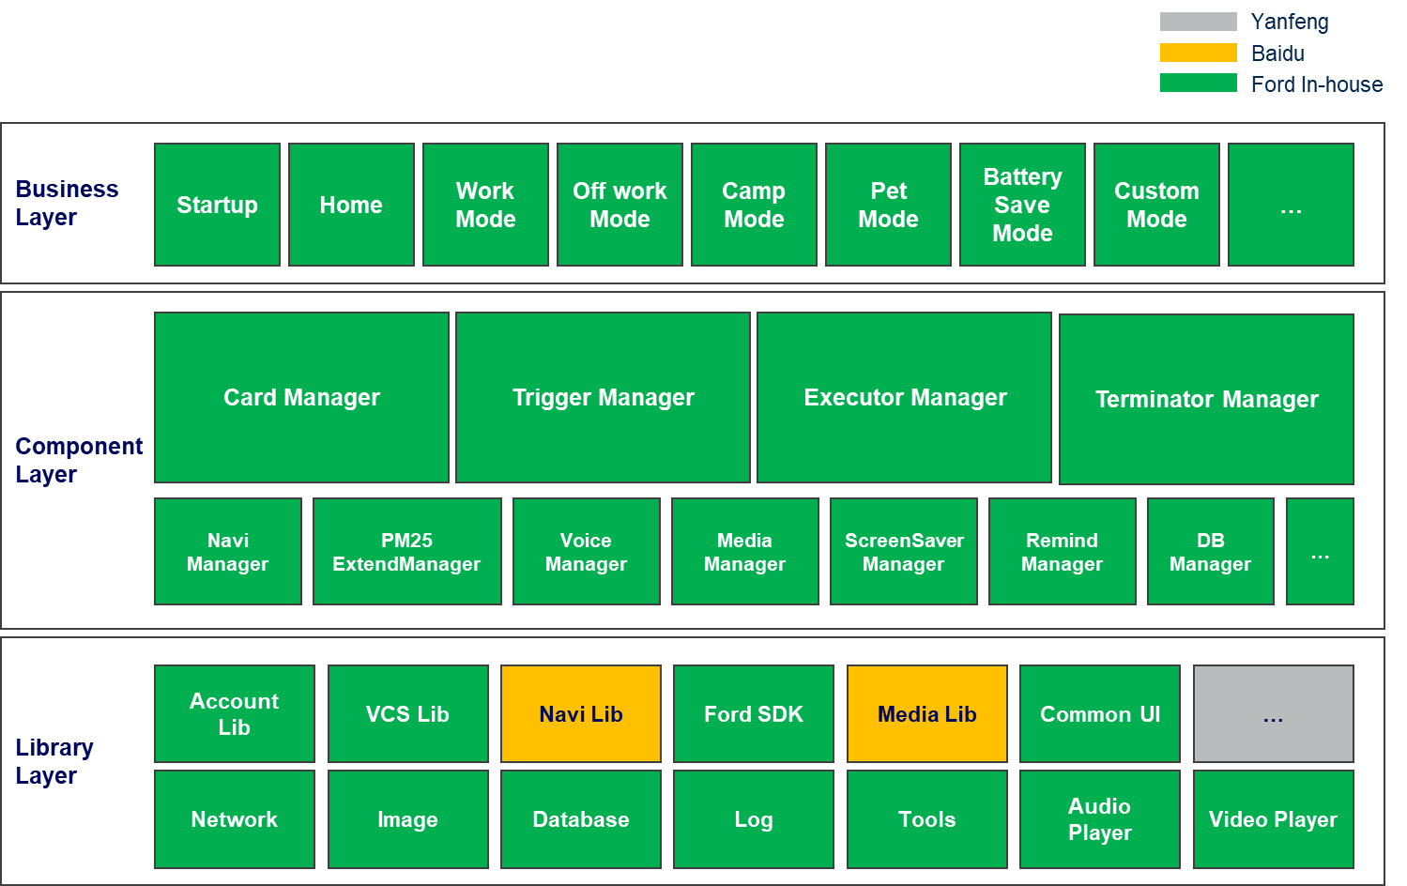

**CX821**

**抽象Card Mode形成Card Manager，Trigger Manager，Executor Manager，Terminator Manager四大组件。**

**设计原则：**

**四大组件自包含，松耦合，标准化南北向接口，横向接口，可以组合创建任意卡片模式，灵活支持业务层的扩展。**

### COMP_01: Custom Mode

|  |  |  |
| --- | --- | --- |
| ID | | MODECARD_COMP_01 |
| Layer | | Mode Card Business Layer |
| Responsibility | | Custom Mode Component |
| Req Allocation | | 1. 展示自定义卡片列表页 2. 展示自定义卡片创建页 3. 创建自定义卡片 4. 保存自定义卡片 5. 编辑自定义卡片 6. 查询自定义卡片 7. 删除自定义卡片 |
| Source | | N/A |
| ASIL Class | | N/A |
| Resource Consumption | Flash | N/A |
| RAM | N/A |
| EEPROM | N/A |
| CPU | N/A |

### COMP_02: Trigger Manager(To be Update)

|  |  |  |
| --- | --- | --- |
| ID | | MODECARD_COMP_02 |
| Layer | | Mode Card Component Layer |
| Responsibility | | Card Trigger Component |
| Req Allocation | | 1. 设置语音触发方式（语音打开） 2. 设置运行周期（一次/重复） 3. 设置运行前询问开关 4. 设置时间触发器（时间范围监听） 5. 设置位置触发器（监听达到终点距离，时间） 6. 设置环境触发器：   查询/监听车内/车外PM2.5，  查询/监听车内/车外温度   1. 设置车辆信信息触发器   查询/监听续航里程，电池电量，车速，档位，充电状态，  预计充电时间，电子手刹，雨量等级，光亮等级，点火状态   1. 设置乘员信息触发器   查询/监听主副驾安全带，后排左中右安全带，副驾状态   1. 设置门窗信息触发器   查询/监听主副驾门状态，后排左右门状态，前舱盖状态，后备箱门状态，全车门锁状态，主副驾车窗状态，后排左右车窗状态   1. 设置导航信息触发器   查询/监听导航状态，所处路段，限速信息 |
| Source | | N/A |
| ASIL Class | | N/A |
| Resource Consumption | Flash | N/A |
| RAM | N/A |
| EEPROM | N/A |
| CPU | N/A |

### COMP_03: Executor Manager(To be Update)

|  |  |  |
| --- | --- | --- |
| ID | | MODECARD_COMP_03 |
| Layer | | Mode Card Component Layer |
| Responsibility | | Card Executor Component |
| Req Allocation | | 1. 空调管理   空调开关，AUTO,温度，风量，吹风模式，循环模式，后窗加热，主副驾座椅空调，方向盘加热，香氛开关，香氛模式，香氛浓度   1. 灯光管理   氛围灯开关，氛围灯颜色，氛围灯亮度，氛围灯模式，日行灯   1. 影音管理   随心听，随心看，Muse，爱趣听   1. 座椅管理   主副驾座椅位置，主副驾按摩开关，主副驾按摩模式，主副驾按摩强度（仅CX821）   1. 设置管理   分屏，熄屏，媒体音量，提示音量，语音音量，电话音量，手机私密模式，驾驶模式，音区，定时，闹铃音，蓝牙连接，无线连接 |
| Source | | N/A |
| ASIL Class | | N/A |
| Resource Consumption | Flash | N/A |
| RAM | N/A |
| EEPROM | N/A |
| CPU | N/A |

### COMP_04: Terminator Manager(To be Update)

|  |  |  |
| --- | --- | --- |
| ID | | MODECARD_COMP_04 |
| Layer | | Mode Card Component Layer |
| Responsibility | | Card Terminator Component |
| Req Allocation | | 1. 手动停止卡片 2. 语音停止卡片 3. 条件触发退出卡片 |
| Source | | N/A |
| ASIL Class | | N/A |
| Resource Consumption | Flash | N/A |
| RAM | N/A |
| EEPROM | N/A |
| CPU | N/A |

### COMP_05: Card Manager(To be Update)

|  |  |  |
| --- | --- | --- |
| ID | | MODECARD_COMP_05 |
| Layer | | Mode Card Component Layer |
| Responsibility | | Card Management Component |
| Req Allocation | | 1. 生成一个卡片实体 2. 设置卡片名称 3. 设置卡片运行触发器（运行方式，运行触发条件，运行周期，运行前询问） 4. 设置卡片执行器 5. 设置卡片终止器 6. 保存卡片配置 7. 查询卡片配置 8. 重置卡片配置 9. 删除卡片 10. 卡片运作状态 |
| Source | | N/A |
| ASIL Class | | N/A |
| Resource Consumption | Flash | N/A |
| RAM | N/A |
| EEPROM | N/A |
| CPU | N/A |

## Software Dynamic Architecture



### Function



#### Startup Mode Card Process

Startup mode card process

|  |  |
| --- | --- |
| ModeCard_Sequence_01 | Functions  Startup Mode Card Process |
| Operation outline  操作概要 | 1. 开机自启动 2. 初始化所有Card数据并启用卡片 3. 初始化语音监听 |

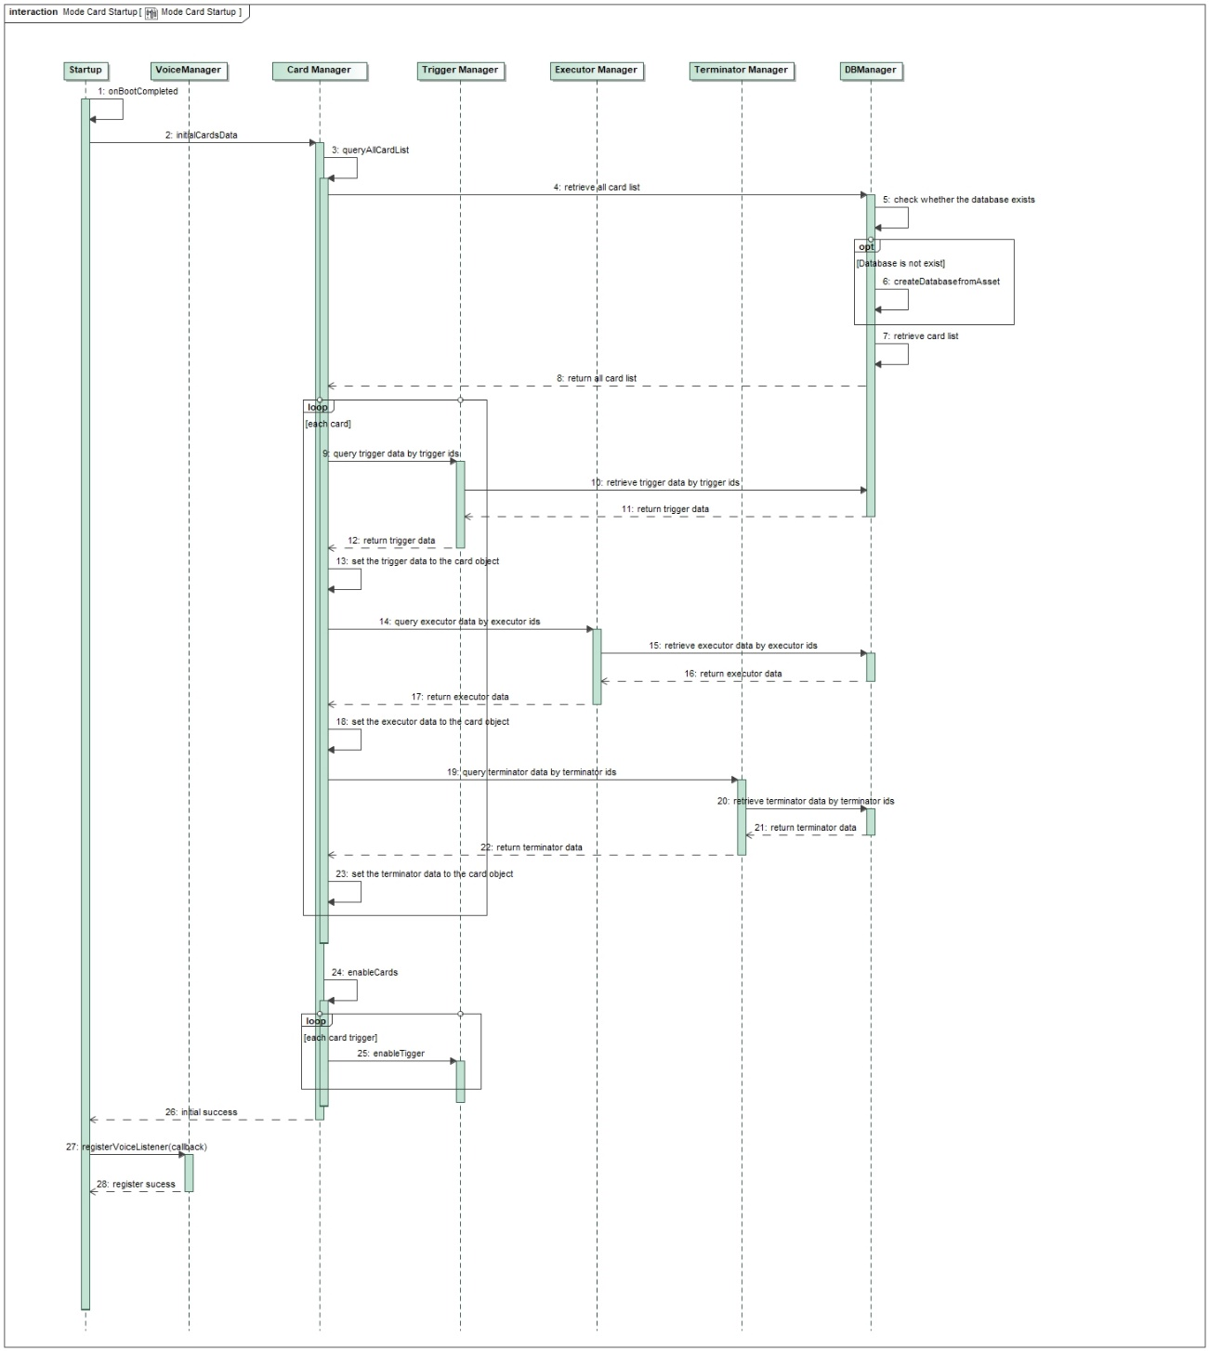

#### View Recommend Card List

View recommend card list

|  |  |
| --- | --- |
| ModeCard_Sequence_02 | Functions  View Recommend Card List |
| Operation outline  操作概要 | 1. 手动打开/语音打开主页 2. 获取推荐卡片列表 3. 展示推荐卡片列表 |

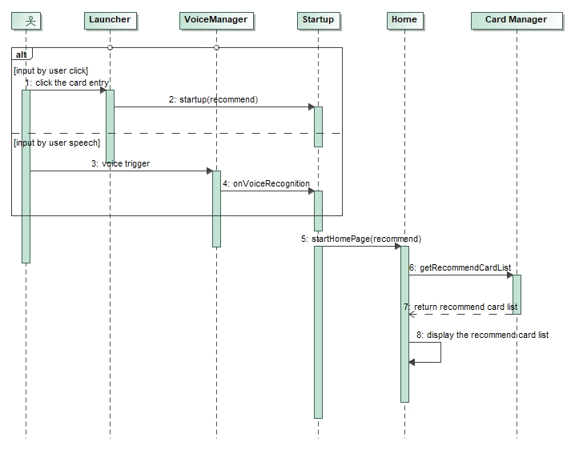

#### View Custom Card List

View custom card list

|  |  |
| --- | --- |
| ModeCard_Sequence_03 | Functions  View Custom Card List |
| Operation outline  操作概要 | 1. 手动打开/语音打开自定义卡片页 2. 获取自定义卡片列表 3. 展示自定义卡片列表 |

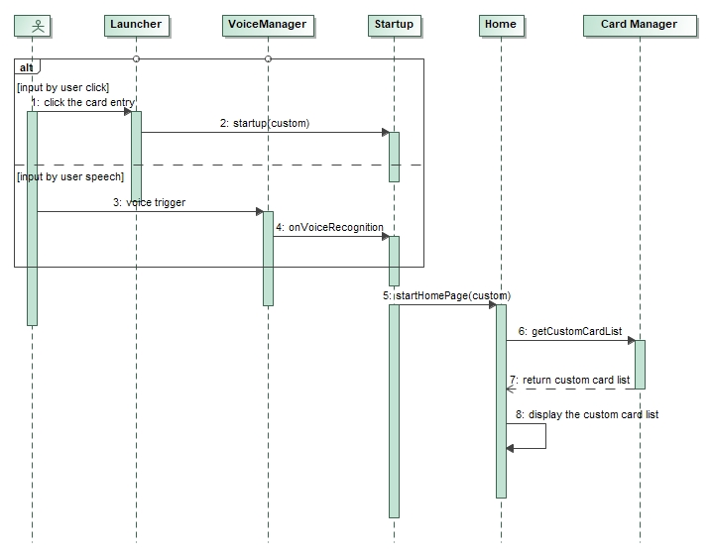

#### Create a custom Card Mode

Create a custom Card Mode

|  |  |
| --- | --- |
| ModeCard_Sequence_04 | Functions  Create a custom Card Mode |
| Operation outline  操作概要 | 1. 创建一个空白卡片 2. 设置卡片名称 3. 设置卡片运行方式 4. 设置运行触发条件 5. 设置运行周期 6. 设置运行询问开关 7. 设置运行任务 8. 设置终止方式 9. 保存卡片 10. 启用卡片 |

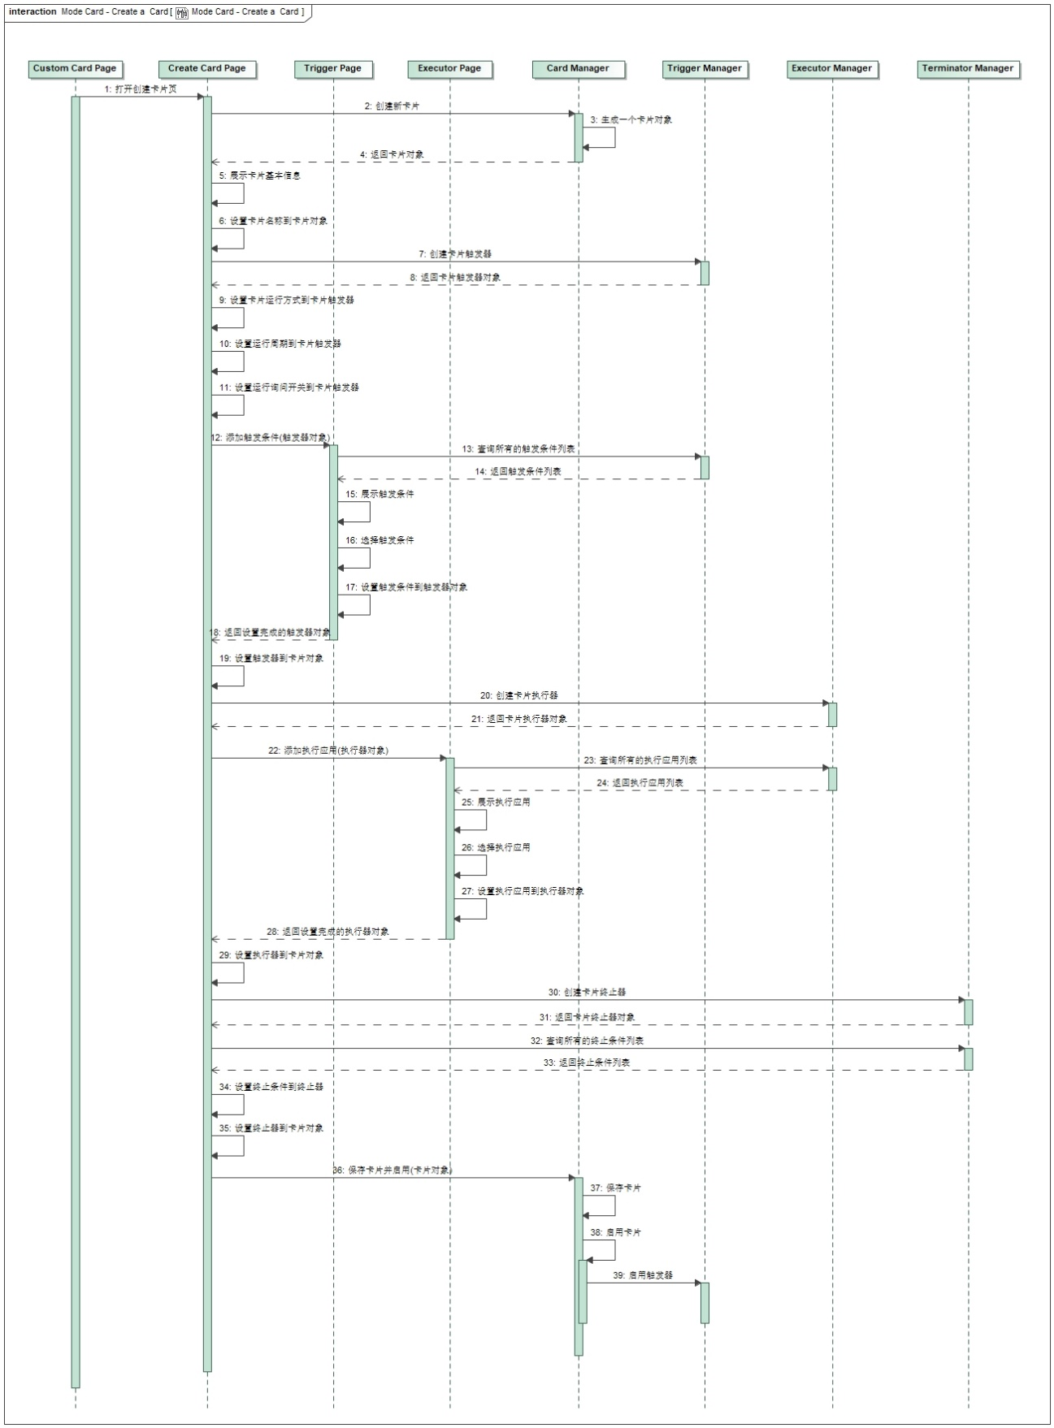

#### Run a Card Mode（To be update）

Run a Card Mode

|  |  |
| --- | --- |
| ModeCard_Sequence_05 | Functions  Run a Card Mode |
| Operation outline  操作概要 | 1. 触发运行条件 2. 运行环境校验 3. 运行提示 4. 运行Card Mode 5. 执行卡片任务 |

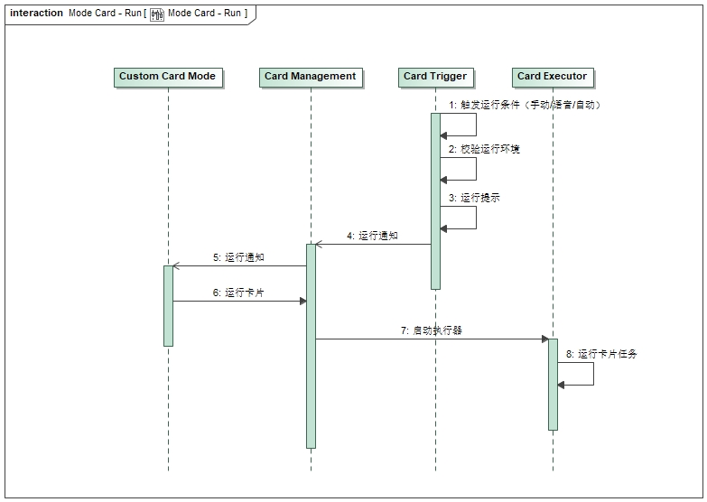

#### Terminate a Card Mode（To be update）

Terminate a Card Mode

|  |  |
| --- | --- |
| ModeCard_Sequence_06 | Functions  Terminator a Card Mode |
| Operation outline  操作概要 | 1. 触发终止条件 2. 终止提示 3. 终止Card Mode 4. 恢复座舱设置 |

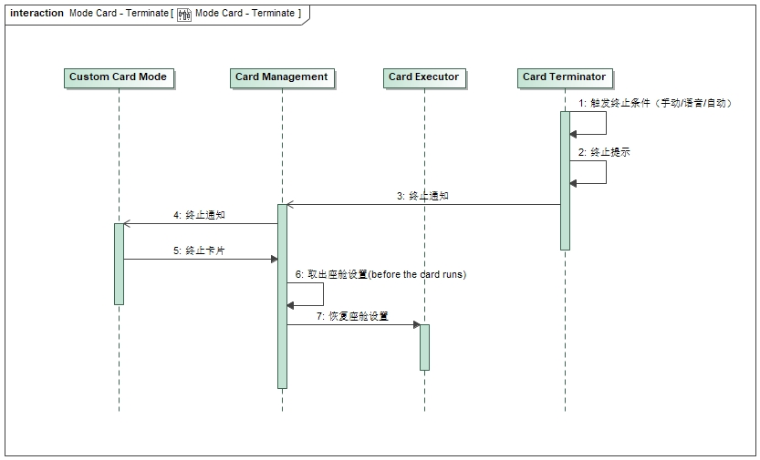

#### Run Camp Mode

Run Camp Mode

|  |  |
| --- | --- |
| ModeCard_Sequence_07 | Functions  Run Camp Mode |
| Operation outline  操作概要 | 1. 手动/语音开启Camp Mode 2. 运行环境校验：   剩余电量>30%,  点火状态为运行态，  档位为P档，  电子手刹已拉起   1. 运行提示（5s倒计时） 2. 运行Camp Mode:   TTS播报，  关闭AEIS,  关闭日行灯，  设置空调，  设置蓝牙电话私密模式，  开启屏保，  熄屏 |

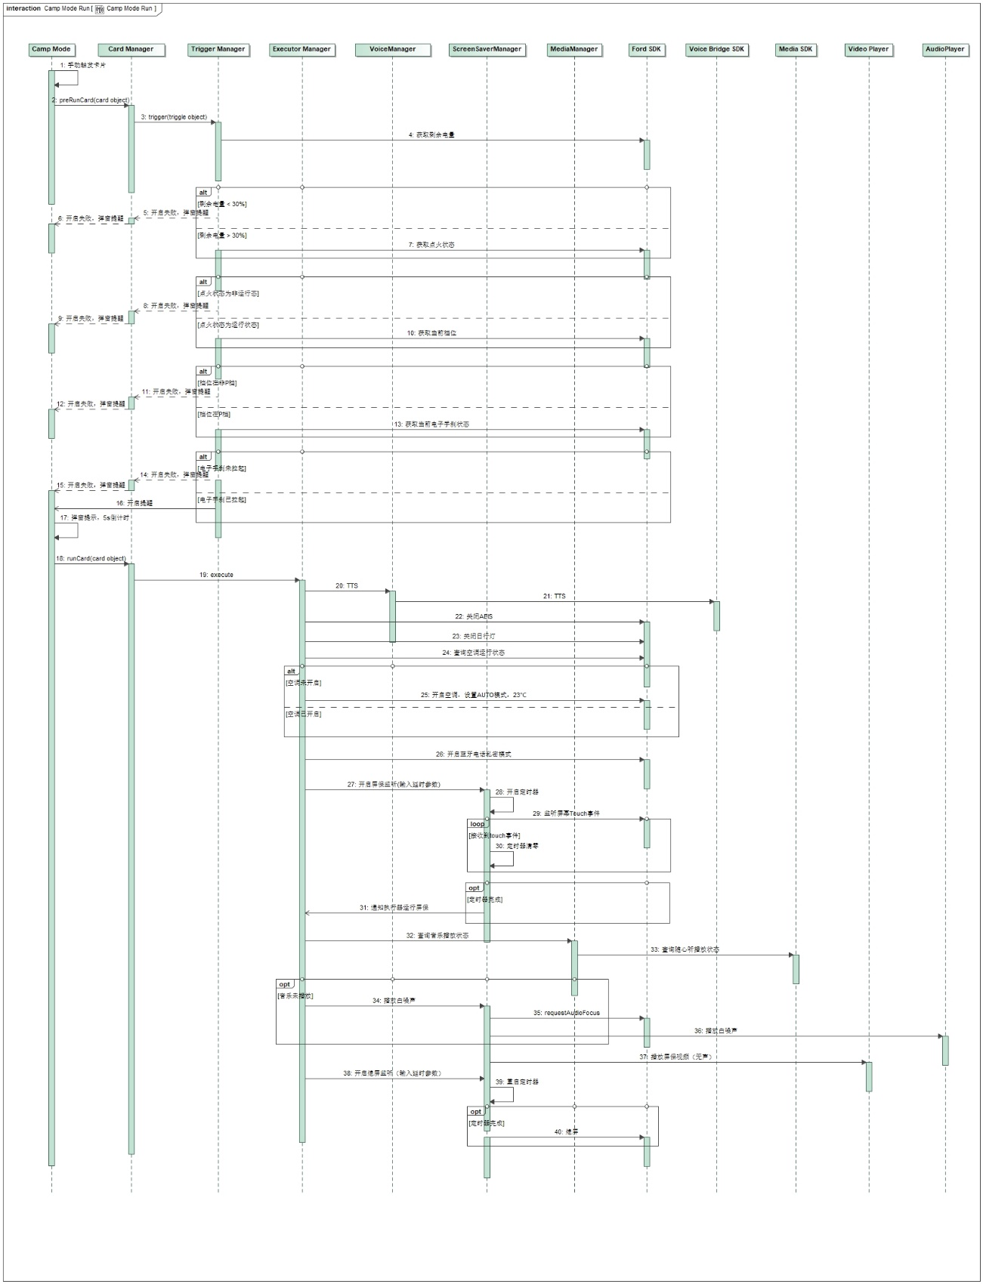



### Safety Mechanism_ASIL

N/A

# Detailed Interface

## Component Interface

## 4.2 Hardware – Software Interface

N/A

# Software control Strategy

## Time Constrains Design and Estimation



## Task Management

N/A

*I*

## Interrupt Service Routines

N/A

## Initialization Processing

## Watch Dog

N/A

## Shared Resources

N/A

# Resource Estimation

## Memory Size Estimation

## CPU Load Estimation CPU